# Project Calculator

Step-by-Step Calculator Guideline

## Create New WPF Project

Open Visual Studio and create new "WPF App (.Net Core)" project

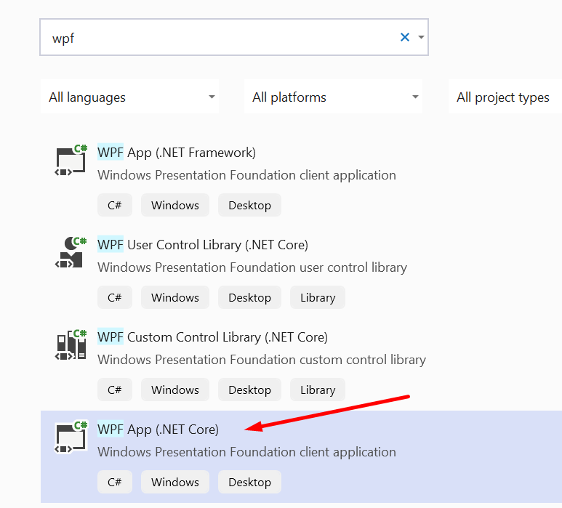

Write adequate name – MyPerfectCalculator

.Net is going to create for you a runnable project, you can run it right away, although it is empty.

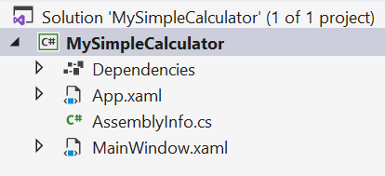

There are some files created, we are going to write in MainWindow.xaml

You can read what XAML is [here](https://en.wikipedia.org/wiki/Extensible_Application_Markup_Language)

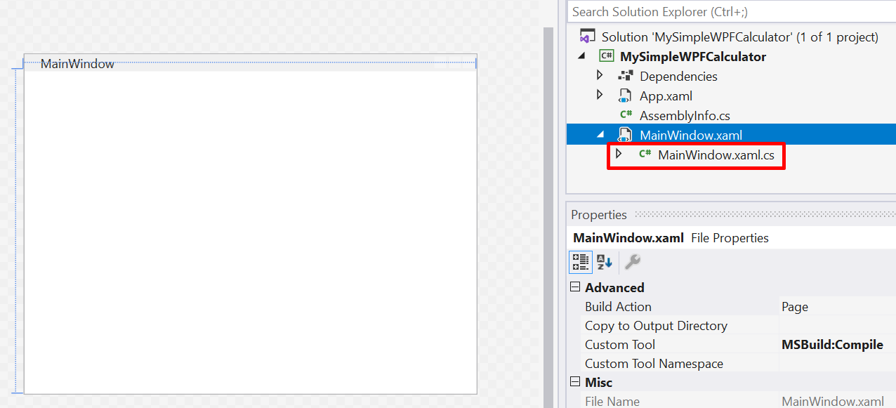

If you expand the MainWindow.xaml, you can see that there is a C# file -> MainWindow.xaml.cs

Here we are going to right our program in C#.

## Open Toolbox

Select MainWindow.xaml -> double click the file. You are going to see the blank main window of our desktop application.

On the sidebar to the left select "Toolbox", the Toolbox menu will open, containing various UI we can add to our window, like buttons, checkboxes, etc.

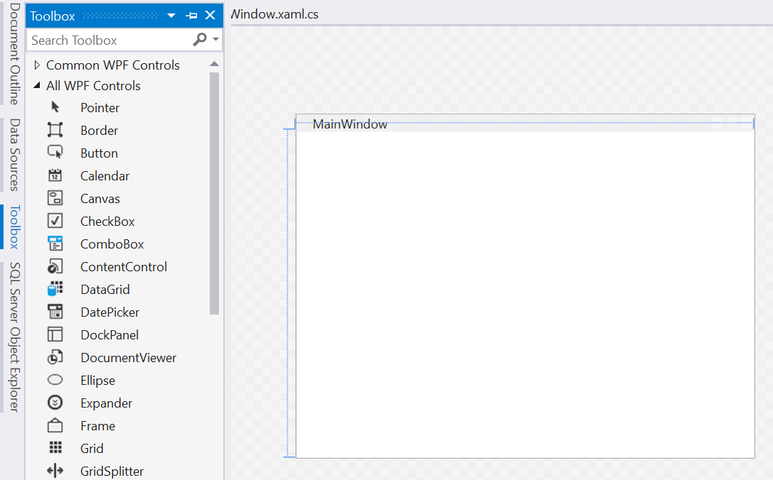

Or you can select – View -> Toolbox (Ctrl + W, X)

Now, let's Add some elements

**Add Elements**

We are going to create calculator like windows calculator. So, we will need button for each number and for each operation and a textbox for the display.

Let's give the elements appropriate names, like ButtonOne, ButtonTwo, ButtonAdd etc.

You can change the alignment of the text, the font size and etc.

If you hover on any property, you will get additional info, so you can understand what the property controls.

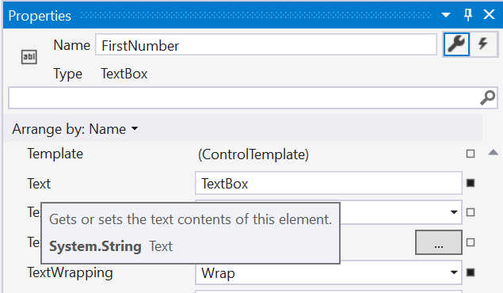

Now, lets add all the buttons we`ll need.

Place them wherever you like, we are not going to concern ourselves with design and user experience for now.

You can also edit the VerticalContentAlignment and HorizontalContentAlignment of the textboxes, so the numbers appear in the middle of the box.

Note that the Displayed text on the button is in property "Content", not "Text", like the displayed text of a textbox.

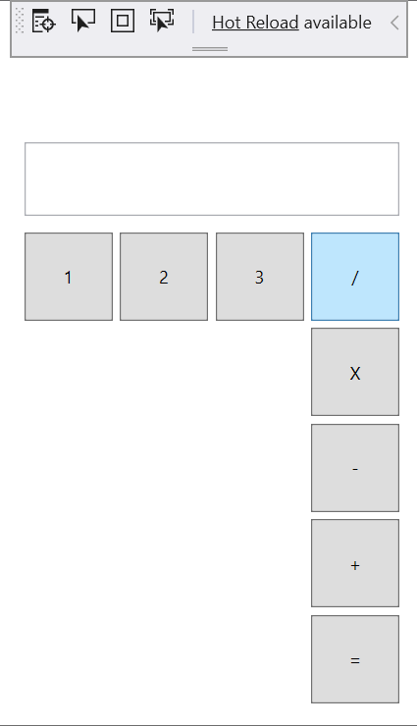

Now we can add the first functionality of our calculator.

## Implement Number Buttons

Double click on each number button.

You are redirected in the MainWindow.xaml.cs file.

ButtonOne_Click and all the other buttons were created for us. Here we can write our logic, for when the user presses any number.

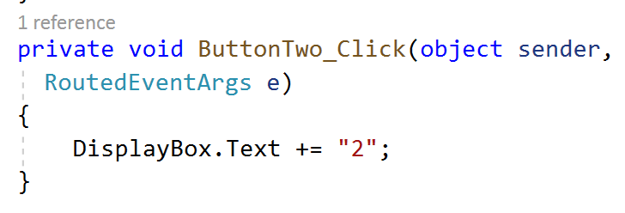

Add the functionality for each number button. We just add the corresponding button to the DisplayBox.Text property.

## Implement Add Button

The code in ButtonAdd_Click will be executed when the button ButtonAdd is clicked.

So now we should do 2 things. First, we need to store the number which the user entered in the DisplayBox somewhere else, and we should store the operator "+" somewhere.

Let’s add another 2 textboxes -> OperandDisplay and OperatorDisplay

Place them right above the DisplayBox.

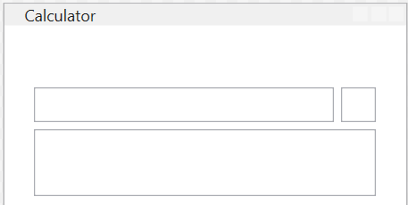

You can set the BorderThickness to 0, so the textboxes won`t be visible.

Now we can implement the ButtonAdd_Click

First, check if there is any input from the user in the DisplayBox.

Then transfer the DisplayBox value to the OperandDisplay Value and add the "+" sign in the OperatorDisplay.

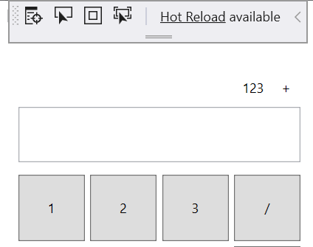

**Good Job!**

Try and add the other operators.

## Implement Equals Operator

When we are done implementing all the buttons. We can add the equal operator.

First, we should check if there are operands and operator.

Then we should use the operator to understand which operation we should use.  
After we calculate the result, we should display the result in the DisplayBox and reset our OperatorDisplay and OperandDisplay.

Good Luck!

**Implement Other Functionalities**

Try implementing dot (.) so the user can enter real numbers, not only integers.

Then continue developing your program logic and functionalities.

## Publish

Right click on MyCoolCalculator project and press Publish.

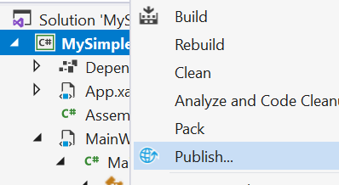

In the next menu just press Create Profile.

After that we need to edit some settings, so we get a nice .exe file in the end.

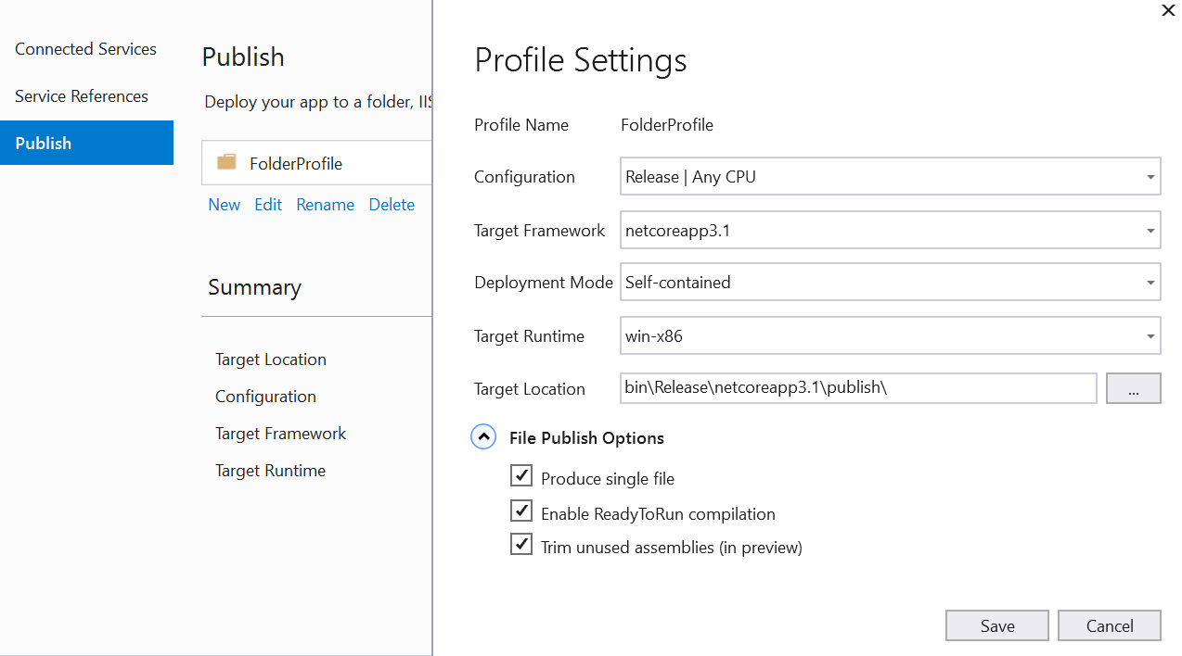

I`ve picked my settings and I am ready to press Publish button

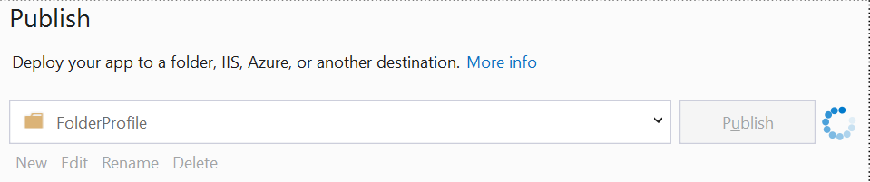

Now open the project folder, by clicking right click on the project -> open folder in explorer.

In the **"bin\Release\netcoreapp3.1\publish\"** folder you can find your MyCoolCalculator.exe

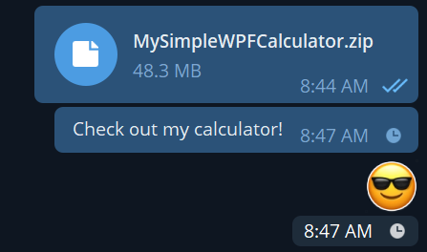

Have fun! Explore! Create!